P. SANNITH

BACKENDENGINEER&DATAANALYST
sunnysunnit@gmail.com | +91 7498461916 | GitHub: Sannith-Hack | Warangal, Telangana

PROFESSIONAL SUMMARY
Highly motivated Backend Engineer and Data Analyst with a 440+ day coding streak. Specialized in optimizing database logic and server-side performance. Expert in building secure, scalable systems using modern frameworks and cloud infrastructures. Dedicated to bridging the gap between scalable architectural design and actionable data insights.

TECHNICAL SKILLS

Languages: Python, TypeScript, JavaScript, Java, C++, SQL, Rust, R Web Stack: React, Next.js, Node.js, Vite, Tailwind CSS, HTML5, CSS3 Mobile & Tools: React Native (iOS/Android), Docker, GitHub, Linux Cloud & DB: AWS, Firebase, Supabase, MySQL, PostgreSQL
WORK EXPERIENCE
Agentic AI Virtual Intern – Brain O Vision Solutions
Jan 2026 - Present
- Developing AI-driven automation frameworks and agentic workflows to optimize organizational efficiency and decision-making.
AWS Cloud Intern – Orbit Learning Pvt Ltd May 2025 - Jun 2025
- Deployed and managed scalable WordPress hosting using LAMP stack on AWS.
- Optimized cloud computing resources for high-availability performance and seamless user traffic scaling.

FEATURED PROJECTS

KUCET College Management System
React, Node.js, Vercel, MySQL

  - Designed an academic portal for Kakatiya University utilizing complex relational schemas to handle thousands of real-time student records and enrollments securely.
NCC Air Wing Dashboard Supabase, React
  - Developed a comprehensive student information dashboard leveraging Supabase for efficient, real-time database management and analytics monitoring.
TODO LIST Mobile Application React Native, TypeScript, Android/iOS SDK
- Built a high-performance cross-platform task manager incorporating native device SDKs for a unified and seamless user experience.

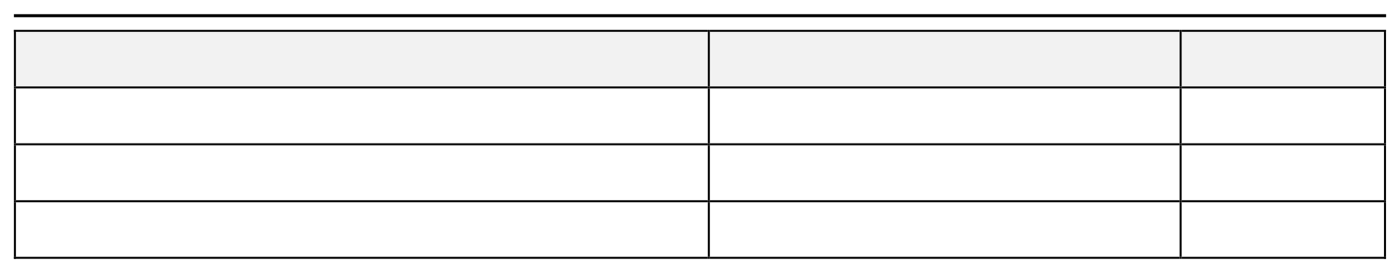
EDUCATION

DEGREE/SPECIALIZATION | INSTITUTE | TIMELINE
B.Tech in Computer Science and Engineering | Kakatiya University (KUCE&T) | 2023 - 2027
Intermediate (MPC) | Geesukunda Jr College | 2021 - 2023
10th Grade | Vikas English School | Grad. 2021

CERTIFICATIONS & ACHIEVEMENTS
- Consistency: Maintained a 440+ Days Coding Streak, demonstrating persistent daily growth and active repository contributions.
- AI & Data: Completed 5-Day AI Agents Intensive Course with Google and earned a Graduate Certificate in Data Analytics from PI LABS (2025).
- Virtual Internships: Successfully completed Deloitte Data Analytics & TATA Cybersecurity simulations.
- Badges & Distinctions: Earned Kaggle Badges (Vampire, Code Forker, Python Coder) and GitHub Achievements (Pair Extraordinaire, Pull Shark)

